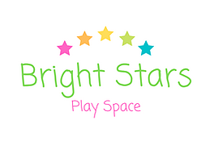

Bright Stars Play Space Assessment and Registration Form
Name of baby | Click or tap here to enter text.
Name of caregiver | Click or tap here to enter text.
Type of session attending (Baby massage/Toddler yoga/Sensory) | Click or tap here to enter text.
Date of first session | Click or tap here to enter text.
Telephone contact | Click or tap here to enter text.
Email | Click or tap here to enter text.
Date of birth for baby | Click or tap here to enter text.
Date of birth for caregiver | Click or tap here to enter text.
Have you and your baby had your 6 week post-natal check up?  (This is not essential for infant massage) | Click or tap here to enter text.
Did your medical professional have any concerns? If so, what were they? | Click or tap here to enter text.
Is there anything that may prevent you or your baby doing gentle stretches? | Click or tap here to enter text.
Is there anything about the birth of your baby and how you experienced the birth, that might be useful to know? | Click or tap here to enter text.
Does your baby have any health conditions (including colic, clicky hips, reflux etc…)? Please give full details: | Click or tap here to enter text.
Do you or your baby have any allergies? | Click or tap here to enter text.
Is there any reason you cannot take part in sessions based on the first floor of the play space? | Click or tap here to enter text.
How did you find out about us? | Click or tap here to enter text.

