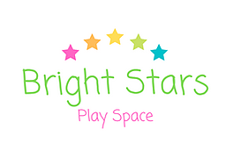

Baby Yoga Safety guidelines

Please read these guidelines carefully before you attend your first class.

What to bring with you:

- Your baby!
- A towel for baby to lie on

Only caregivers work with their own baby.

When practicing with your baby, never rush or force anything. If you feel stressed or tense, just take a break and come back to the practice later. Always ensure that you feel safe, secure and confident with the way you are holding or working with your baby. Never do anything that you do not feel comfortable with.

If your baby is unwell, it is best not to attend the Yoga class. If your baby is crying excessively and cannot be comforted, he/she may be ill. Never practice on a distressed baby, or if your baby is limp, pale, has a temperature or any difficulties breathing. Please seek appropriate medical help.

It is not recommended to practice within 24 hours of your baby’s immunisations.

Thanks M & C.

Disclaimer

Please sign the following disclaimer.

- I have read the above safety guidelines and will ensure that I adhere to them.

- I take full responsibility for myself and my baby and for everything that happens to me and my baby in relation to the Baby Yoga class.

- If I have any doubts, I will seek the advice of my medical professional before proceeding with Baby Yoga classes.

- I will keep the Baby Yoga Teacher informed of any health issues that arise over the course of the classes, both for me and my baby.

- I understand that refunds are not possible for missed classes.

Signed: …………………………………………….………….….

Date:……………………………

Thank you for completing this form. The information you give is treated as confidential.

